The Wall That Heals Crivitz 2023

June 1st – 4th, 2023

Crivitz – Stephenson Area Museum

N104 Oak St Crivitz, WI 54114

ESCORT THE WALL THAT HEALS TO CRIVITZ
The 53’ trailer that carries The Wall That Heals to Crivitz arrives Tuesday, May 30th, 2023. Please join us in supporting our Veterans by joining the escort from Vandervest Harley-Davidson to Crivitz. A Welcome Back procession will take place through downtown, ending at the Crivitz – Stephenson Area Museum, where The Wall will be displayed from June 1st – 4th. Please see the backside of this flyer for a map of the route.

Ways to join the escort
Motorcycles: If you ride a motorcycle and would like to escort our fallen service members, we invite you to lead The Wall to Crivitz with our First Responders. Line up for the escort will Tuesday, May 30th at 2:00 pm in the Vandervest Harley-Davidson parking lot. Please email our Escort Captain Shawn Veriha to let him know how many motorcycles will be joining the escort. Departure is planned for 4:15 p.m.
Observers: Please join us along the route to welcome our veterans home.
Veterans: We invite Vietnam Veterans that would like to join the escort on its final journey from Crivitz Community Veterans Park to the Crivitz – Stephenson Area Museaum to join us. We will have wagons and UTVs for you to ride in along the final leg of the escort route. Please email Kaitlin Deschane if you would like to take part. When emailing or calling, please indicate your military branch and when you served.

For more information - Please email Shawn Veriha or Kaitlin Deschane - sveriha@vocwi.com, kdeschane@vocwi.com or call for more information at 715.927.0241
The Wall That Heals is open 24 hours a day Thursday through Sunday, closing at 2:00 pm, Sunday.

For more information about The Wall That Heals – Crivitz 2023, please visit villageofcrivitz.com/twthcrivitz or on Facebook at The Wall That Heals Comes to Crivitz

ESCORT ROUTE

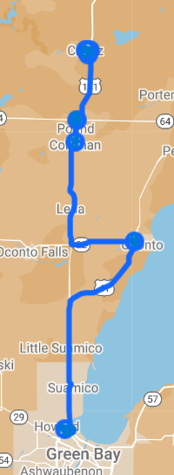
Through Oconto
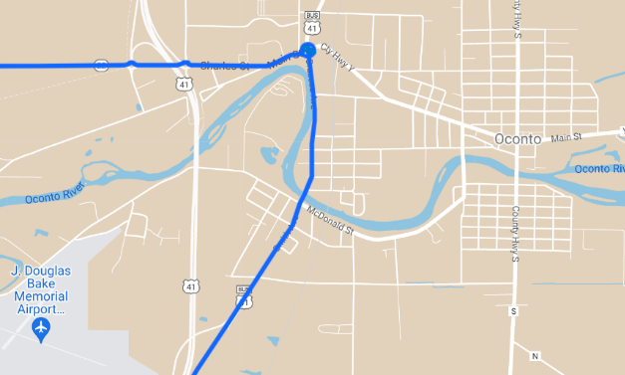

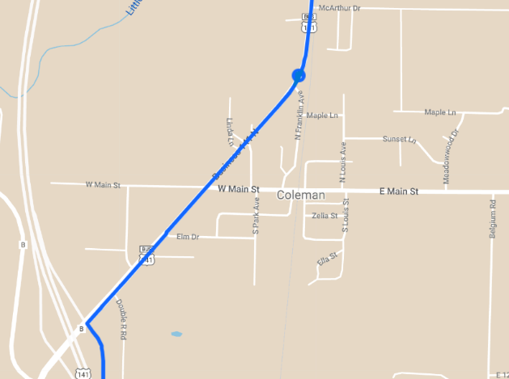

Through Coleman

Through Pound
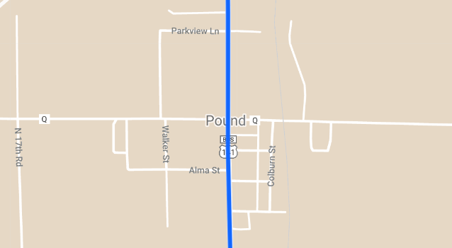

Through Crivitz

